CONVERT AND EDIT MOFLEX - BY RD2K3

- tested on windows 7 ultimate x64 (updated). I think it makes no difference, but I also have k-lite mega pack codec 11.0.0, vlc 3.0.7.1 and net framework 4.8

- The programs are downloaded from random sites and from the website below:
https://developer.nintendo.com/group/development/wtc6ppr2/downloads

- does not contain virus or malware (I am a computer technician for 15 years)

------------------------------------------------------------------------------------------------------------------------

- install Mobiclip_Multicore_Encoder and license file
if you have troubles during conversions, go to:
%appdata%\Mobiclip\Mobiclip Encoding Tool
and delete all files from this folder, except User_CTR.lic

- install Mobiclip_Tools (from CTR_MW-Mobiclip folder), license file and DLL's

- install AviSynth_260.exe (for 3d video)
NOTE: size increases 10% to 15% in 3D videos and decreases by the same proportion in 2D videos

- run VideoEditorPlus.reg

------------------------------------------------------------------------------------------------------------------------

- Place the moflex video inside the Mobius.v1.1 + ffmpeg x64 folder and drag it to Mobius.exe to generate a mp4 file

------------------------------------------------------------------------------------------------------------------------

- open convert-project.mograph with MobiclipMulticoreEncoder
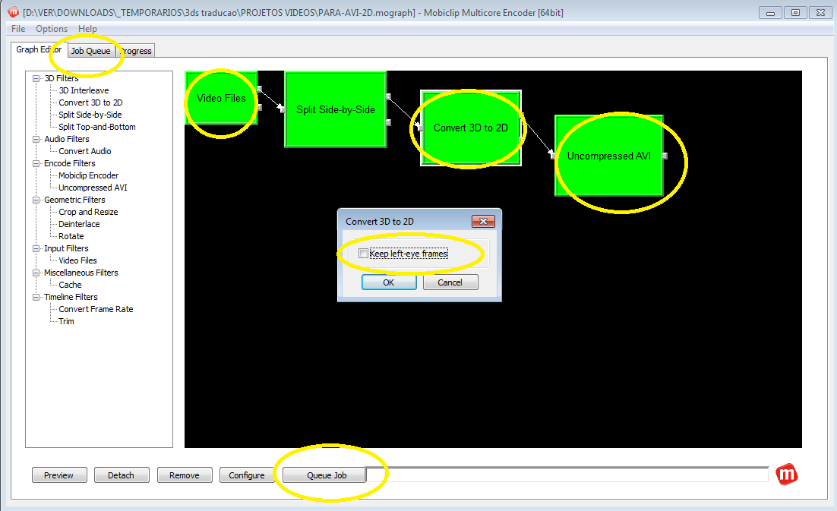

- double click on video files and select mp4 file generated above

- click on uncompressed AVI and choose the destination folder

- click on queue job (you can view conversion status on the job queue tab)

- rename your converted video.avi to video-LEFT.avi

- click on convert 3D to 2D and uncheck the checkbox keep left-eye frames (for 3d video)

- click on queue job (for 3d video)

- rename your converted video.avi to video-RIGHT.avi (for 3d video)

------------------------------------------------------------------------------------------------------------------------

- open the VideoEditorPlus in folder Movavi Video Suite 17.4.0

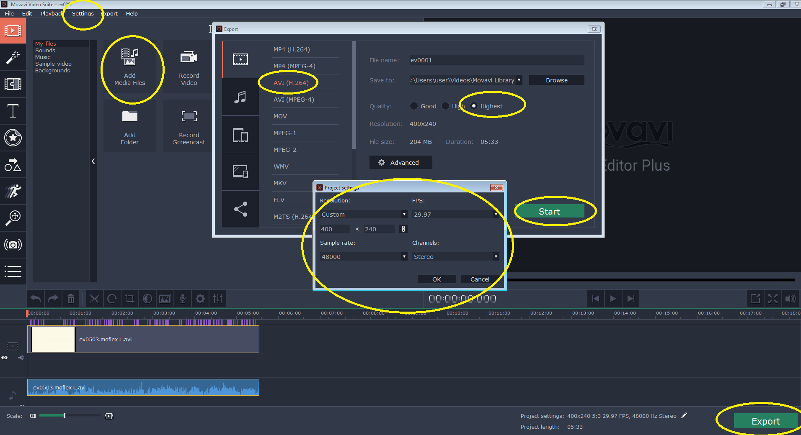

- go to configurações, idioma, english (if you have trouble, go back to português brasileiro, because i didn't test in english)

- go to add media files, choose your video-LEFT.avi and edit it

- after finish, go to export and leave the same settings as the photo below
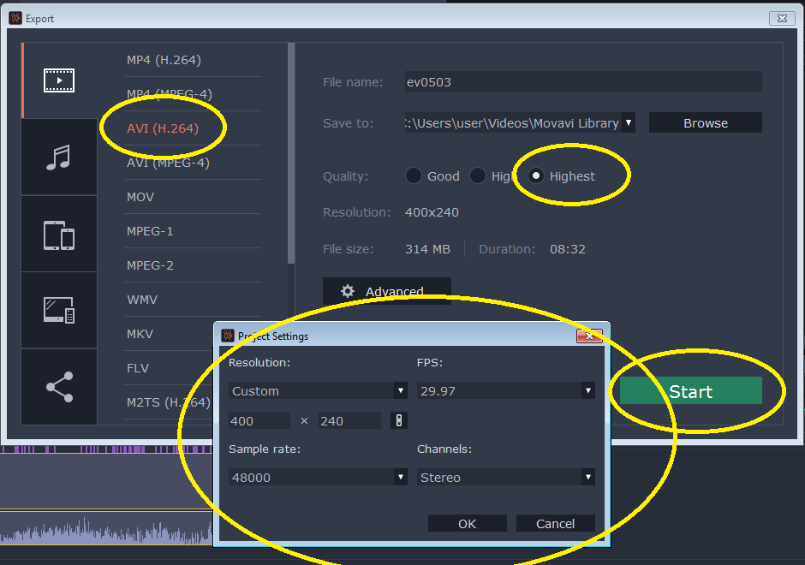

- repeat the procedure with the video-RIGHT.avi (for 3d video)

------------------------------------------------------------------------------------------------------------------------

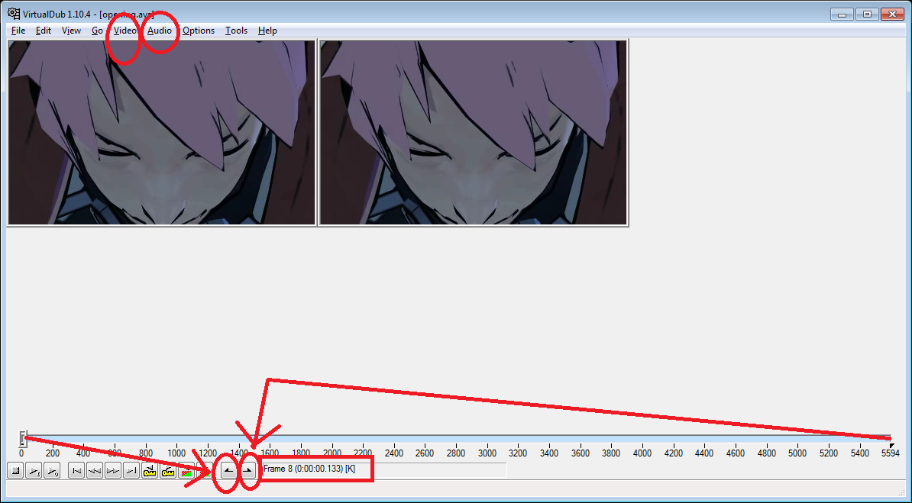
- after generating the 2 edited files, put the sample-for-vdub.avs in the same folder (for 3d video)
- open and edit it with notepad, so that the video names are the same as yours (for 3d video)

- open virtualdub and drag the sample-for-vdub.avs into it (for 3d video)
NOTE: If you want to generate 2D video, just drag video-LEFT.avi to virtualdub and ignore the sample-for-vdub.avs
- click 8x with the  on your keyboard and mark the frame 8 as start frame (because of a bug where the screen goes green). Drag to the last frame and mark as final frame (see the red arrows on picture above)

- go to audio, full processing mode
- audio, compression, select NO COMPRESSION (PCM)

- go to video, full processing mode
- video, compression, select mobiclip for nintendo CTR

- file, save as avi

------------------------------------------------------------------------------------------------------------------------

- After generating your avi, open msdos (CMD) and with the "cd" command, set the directory where is the video generated by virtualdub

- to finish, type the following command
moflextool -avi your-video-name.avi -video -audio -timeline -out output.moflex -info

- to test the moflex converted videos, use MobiclipDecoder

------------------------------------------------------------------------------------------------------------------------

- if you inject the moflex videos into the CIA game file, they will play perfectly

- if you use LUMA game patching, they will run very slowly

